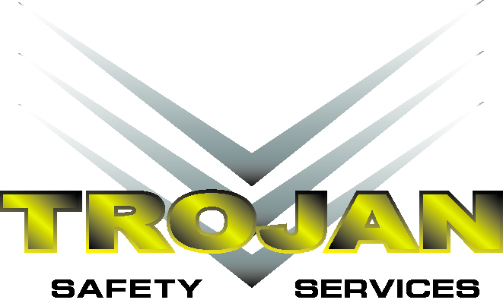

Sales Representative

Trojan Safety Services AB Ltd in Weyburn Saskatchewan is seeking a Sales Representative to sell and service customers in a manner which exceeds their expectations. The Sales Representative will develop and maintain relationships with customers.

**Qualifications**

* Valid Driver’s Licence with clean abstract
* Previous sales experience preferred
* Previous customer service experience preferred
* Relevant business experience in drilling/oil and gas production is desired
* Good communication and people skills
* Explaining the value of our services
* Responsible for developing, cultivating and growing customer base.
* Communicates and strategizes with the sales team on all related client issues

**Character Traits**

**Sales Representative will be working in close proximity to crews and must maintain an air of**

**“Friendly Professionalism”. They must also show the following character traits:**

* Confidence
* Responsible
* Practical
* Patient
* Ability of relating to wide range of individuals
* Being extremely safety conscious
* Remaining calm in emergencies
* Ability to direct workers in the event of a medical emergency
* Have effective communication skills
* Have effective problem solving and decision making skills

**Our Safety Sales Representatives enjoy:**

* Competitive Pay
* Medical, Dental and Vision Insurance Package
* Disability and Life Insurance Package
* Career Advancement Opportunities